Algorithms semester 2 assignment 2
Q1.
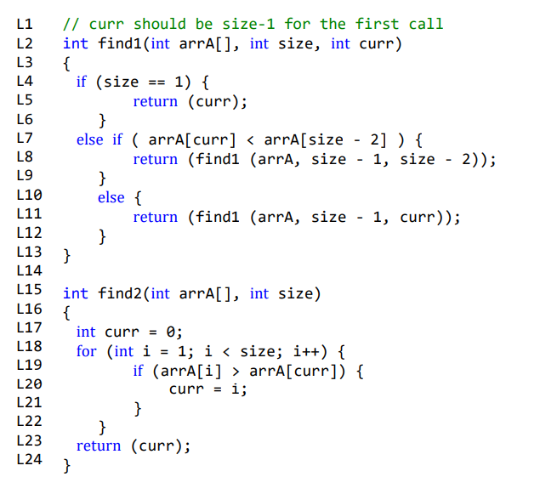
- A recursive function makes references to itself. A well-defined recursive function will not proceed to run indefinitely. It must have two properties, base case and reduce. A base case must have a condition so that the function does not call itself and will stop, this is called a stopping condition. In the function find1 we see the base case is L4, this ensures there is a condition so the function doesn’t call itself. Reduce means for each recursive call(when the function calls itself), directly or indirectly, it must move towards the base case. In find1 we see a reduce case in L8 and L11, they return/reduce to base case to solve the problem L5 is not a reduce case as it stops the recursion whereas the other two lines bring it back to the base case. A well-defined recursive function has these two properties.
- Timestep analysis: worst case scenario

Find1:
Line | Cost | numTimes | Cost*numtimes | Total
L4 | 1 | N | N | N
L5 | 1 | 1 | 1 | 1
L7 | 1 | N | N - 1 | N - 1
L8 | 1 | Worst case | -
L11 | 1 | 1 | N - 1 | N - 1
 |  |  |  | 3N - 1

L4: is the base case and will run N times in the worst case as size will be reduced by 1 each time until it reaches 1 and returns(curr). The array must be in ascending order as this will cause the function to take the most amount of time as curr will always be bigger than any other position in the array as the size decreases into a position less each time until it gets to position 1. The function compares curr which is position 7 to each position in descending order until it gets to position 1 when size == 1. This is the maximum amount of times this can run until size is equal to 1. On the Nth time size will = 1.

L5: will run once after finally (size == 1) on the Nth run.

L7: will run N – 1 times as on the Nth time curr will be returned and will stop executing the program meaning it will not reach L4 on the Nth time.

L8: will not be executed once in the worst case as curr will always be greater than size – 2 therefore this line is ignored

L11: this line will also run N – 1 times in the worst case as on the Nth time L5 will return(curr) completing the program so it will not reach this line.

Find2:
Line | Cost | numTimes | Cost*numtimes | Total
L17 | 1 | 1 | 1 | 1
L18 | 1 | N + 1 | N + 1 | N + 1
L19 | 1 | N | N | N
L20 | 1 | N | N | N
L23 | 1 | 1 | 1 | 1
 |  |  |  | 3N + 3

L17: initiated curr so it runs only once in find2()
L18: runs N + 1 times, it will continue to run and increment i until it is greater or equal to size
L19/L20: all run N times as once i is greater or equal to size the rest of the program is executed until it reaches return(curr) and including as there is no reduce case in the find2 function. Return(curr) always returns the curr value each time the program is executed.
L23: runs once after arrA[i] < arrA[curr]. Each time I is incremented and curr = i after the for loop runs.
Q2.
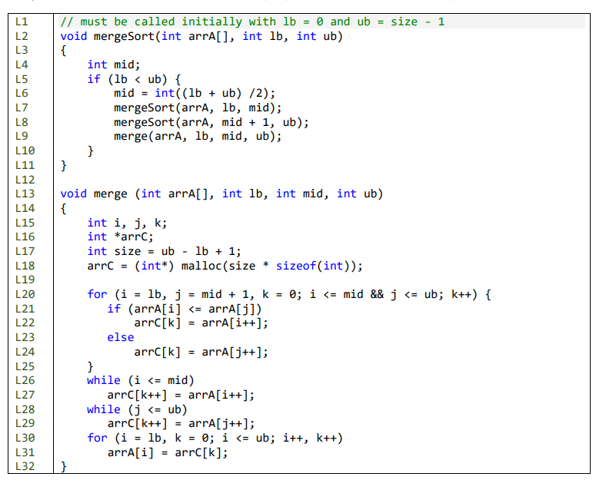
- How does merge() work?: sorted array[8]= {2,6,5,1,4,3,9.7}
- Uses the function mergeSort() to get the value for mid in L6.
- We also see in L7-L9 mergesSort() merges array 1 and array 2 and then returns both to to merge function in l9.
- In L18 we create arrC to be the size needed for the current merge
- The purpose is to merge split arrA[i] and arrA[j] into smaller sub-arrays eg {2,6} and {5,1} and keep sorting and merging until we get two sub-arrays {1,2,5,6} and {5,6,7,9} when we merge these two arrays into one array – {1,2,3,4,5,6,7,9}
- The index values are set up to divide the array into two sub-arrays. Lb to mid, Mid + 1 to ub eg 0-3 and 4-7
- we create arrC[] to be the same size as the portion of arrA[] and index k will be used to traverse arrC[].
- In L20 we initialise indexes to the start of both portions of the array and also initialise K. i = lb, j = mid + 1, k = 0
- In L21-L24: we compare the value of arrA[i] and arrA[J], in doing so we divide the arrays into smaller arrays until we gets to the smallest unit and so we update relevant indexes until the first array is sorted.
- Once the comparisons have finished in the for loop, the while loops write out the rest of the array without comparison. L26 writes out what’s left in arrA[i] and L28 writes out what’s left in arrA[j] and removing the elements from their previous array.
- In L30/L31: the function writes back from arrC to arrA so the correct values are in place for the next merge.
- Merge() sorts both sub arrays into a smaller sub-array and sorted order then compares the values from each array and swaps them in order to place the smaller values first merging both arrays into two sub-arrays, comparing and swapping then doing the same to create one big sorted arrC[k}.
- Written explanation:
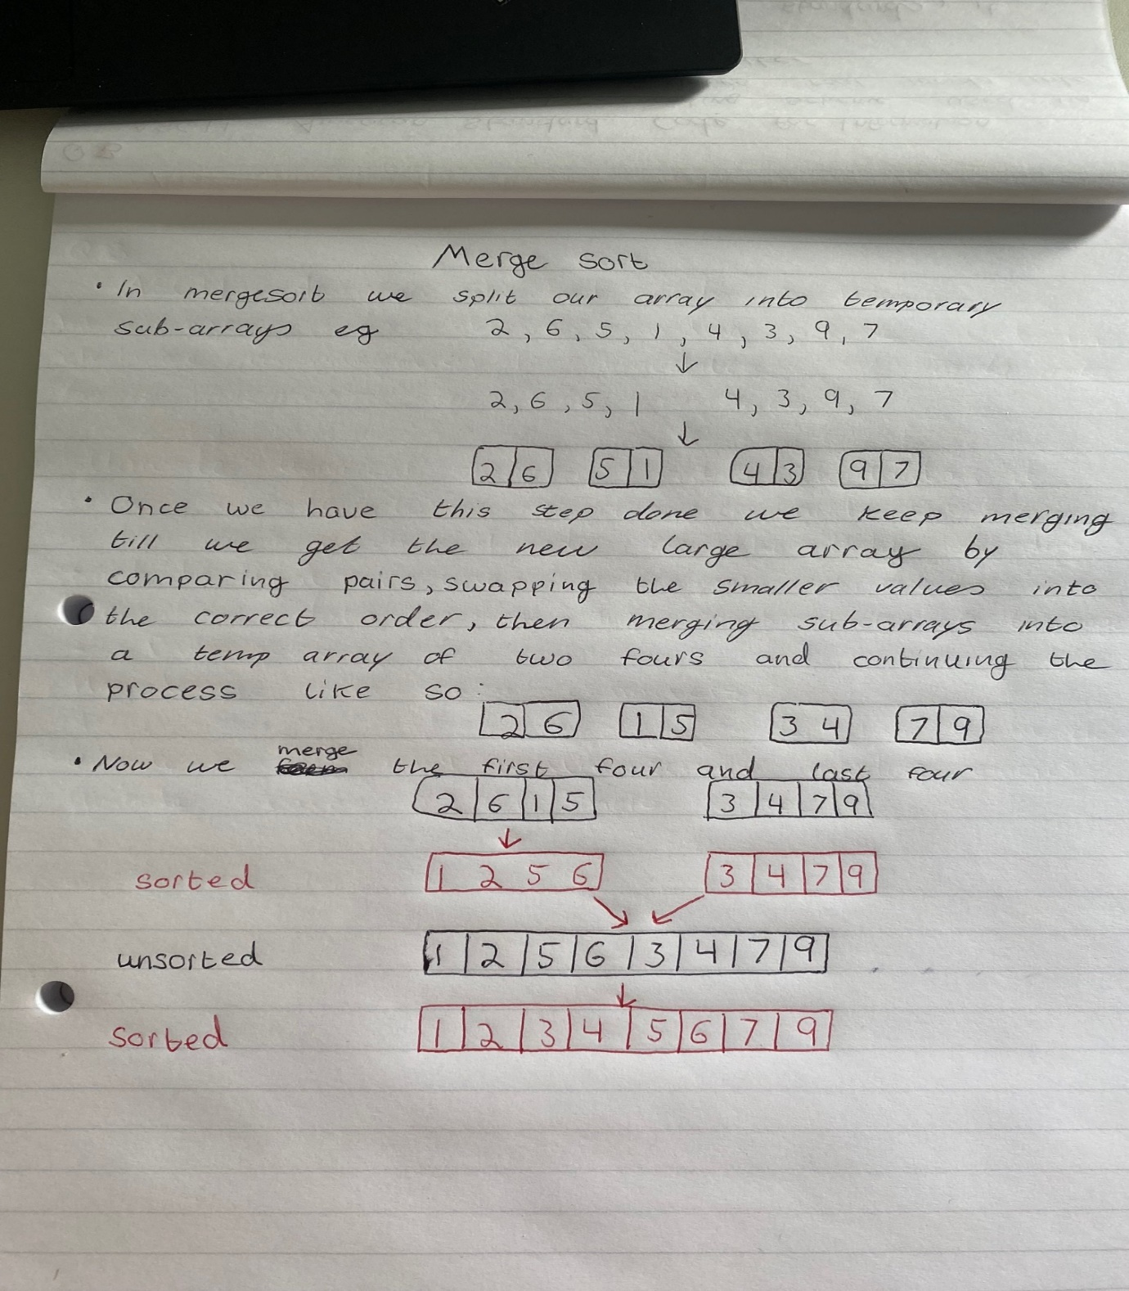

Q3.
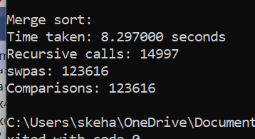
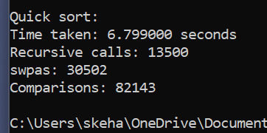
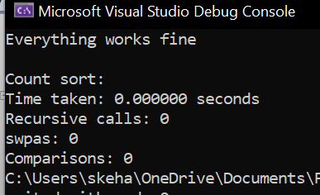
- Advantages/disadvantages
Merge sort is a recursive algorithm.

Advantages: is quicker for larger lists because it doesn’t go through the whole list several times making it faster than other algorithms in this case. It has a consistent running time as it carries out different bits with similar time in a stage.
Disadvantages: it is slower compared to other algorithms for smaller task. This is why it is the slowest in this case above. It will also go through the whole process even if the array is already sorted which is using unnecessary time.

Quick sort picks elements as a pivot and partitions the given array around the picked pivot.
Advantages: is quick and effective method of sorting a list of any size array as any value can be selected and act as a pivot. The algorithm doesn’t require additional storage space and exhibits good cache locality making it faster. Its time complexity is n(log n).

Disadvantages: in the worst case time complexity O(n^2) when the largest or smallest element is in the pivot or when all the elements are the same size the time complexity is increased greatly. This is why we have a high time complexity in the output.

Count sort: count sort is a non-comparison sorting algorithm. It sorting by mapping the value of each element as an index of the auxiliary array.

Advantages: its running complexity is 0(n) and as seen in the output and is often used as a sub-routine to another sorting algorithm. it is faster than merge and quick sort. It is efficient if the range of the input data is not significantly greater than the number of objects to be sorted. It can also be extended to work for negative inputs.

Disadvantages: cannot be used for array with non-integer elements because otherwise the array of the frequencies cannot be constructed. If non-primitive elements are sorted another help array is needed to store elements.

Merge sort: has the greatest amount of calls, comparisons and swaps as it is a recursive function
Advantage: it doesn’t reads through the list several times. Its very efficient for larger lists. It is very effective for larger arrays.
Disadvantage: even if the array is sorted it still goes through the process of comparing. It takes too long to process for smaller lists. It is very slow compared to other algorithms for smaller arrays.

Quick sort: is quicker than merge sort. It has a close amount of calls but swaps and compares a significantly less amount of times.

Advantages: it is quicker than merge sort considering they are both divide and conquer functions as it has less swaps, comparisons and calls. It is effective for any size array unlike merge sort.
Disadvantages: the split stage is more complex than the merge sort stage. The worst case is very poor leading to more swaps, comparisons and calls.

Count sort: has O(n) time complexity unlike the other two sorting algorithms. It is not a comparing function so it has no swaps, comparisons or calls. It works by counting the number of objects and using arithmetic to calculate the position of each object in the output sequence.
Advantage: we don’t have to swap, compare or call as it is a non-comparative function. It has a time complexity of O(n) so it sorts in no time.
Disadvantes: it wont sort for non-integer elements. It is inefficient if the range of values to be sorted is very large.
Where the lines of counting were:
Merge sort:
if (lb < ub) {
mid = ((lb + ub) / 2);
mergeSort(arrA, lb, mid);
recur++;
mergeSort(arrA, mid + 1, ub);
recur++;
merge(arrA, lb, mid, ub);
recur++;
while (i <= mid && j <= ub) {
comparisons++;
swaps++;
if (arrA[i] <= arrA[j]) {
arrC[k] = arrA[i];
i++;
}
else {
arrC[k] = arrA[j];
j++;
}
k++;
} //end while

// write out anything left in i part
while (i <= mid) {
comparisons++;
swaps++;
arrC[k] = arrA[i];
i++;
k++;
}
// write out anything left in j part
while (j <= ub) {
comparisons++;
swaps++;
arrC[k] = arrA[j];
j++;
k++;
}

Quick sort:
if ((endval - startval) < 1) {
return;
}
else {
int k = partition(arrA, startval, endval);
//now sort the two sub-arrays
quickSort(arrA, startval, k - 1); //left partition
recur++;
quickSort(arrA, k + 1, endval); //right partition
recur++;
}
for (k = startval + 1; k <= endval; k++) {
comparisons++;// k keeps incrementing to the end
if (arrA[k] <= pivot) {
i++; // i only increments when there is a new value to add to the <= portion
if (i != k) {
swaps++;
swap(&arrA[i], &arrA[k]);
}
}
}
swap(&arrA[i], &arrA[startval]);
swaps++;
recur++;// put pivot in correct location i
return(i);

Count sort has no swaps or comparisons to count.

Plagiarism Declaration: “I am aware of what plagiarism is and include this here to confirm that this work is my own”

